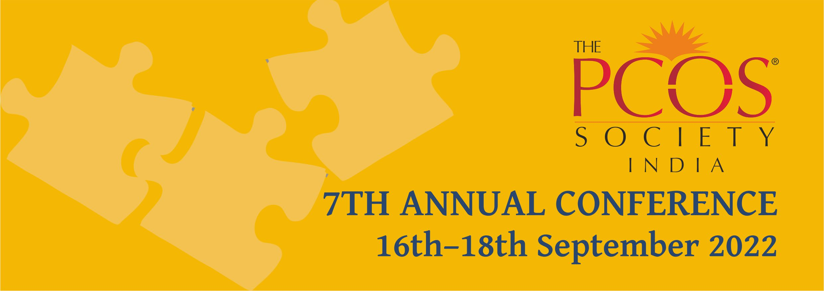
Abstract Submission Form
The Organizing Committee invites Oral / Posters presentations from registered delegates of this conference. Please fill the form below and send it to pcosconference2022@ftcevents.com
The areas to be covered could be related to any problem related to PCOS.
All participants wishing to present papers / posters must be registered delegates.
Name of Presenting Author : ____________________________________________
Specialization : _______________________________________________________
Address : ___________________________________________________________
Mobile No.: ________________________ Telephone No.:____________________
Email Address : ______________________________________________________
Name of Institution : __________________________________________________
Abstract for : Oral Presentation Poster Presentation
Co-Authors : ________________________________________________________
Subject : ___________________________________________________________
The Content of your Abstract should be typed in the box below.

- The abstracts should not be more than 250 words.
- Last date of Submission : September 5th, 2022
- Poster/Oral presentations will be scheduled on Saturday 17th or Sunday 18th September 2022.
- All presenters will be given a Certificate for the presentations
- Prizes will be awarded to the 3 best Oral / Poster presentations

